- Items must be in GOOD CONDITION. That means, no holes, no stains, and no discoloration. If your item is not in good condition, we will not attempt to sell it.
- Items should be clean.
- Items should be neatly folded.
- If an item has been altered, please make a note of that on the tag.
- We can ONLY accept and sell Dennis Uniforms.
- Only attach your tag with a SAFETY PIN. No staples or straight pins. This is to protect the garment (and our fingers). If you need safety pins, Just ask!
- Register online (must be done each time you bring in new consignments). https://forms.gle/oM55cmJKAFUnDCMf9
- Complete the inventory sheet with item numbers, description, size, price.
- Attach a tag with a SAFETY PIN to the top right side of the garment. Please use the tag template provided an example below.
- Drop off your items to the designated place/time noted on the upper left.
- Unless otherwise indicated, PTO will keep your items for the next sale. Tags will remain on the garments and you will receive payment for those items. If you wish to have your items returned, you must indicate on your
- Consignor Info Sheet and online registration.


Tagging Examples 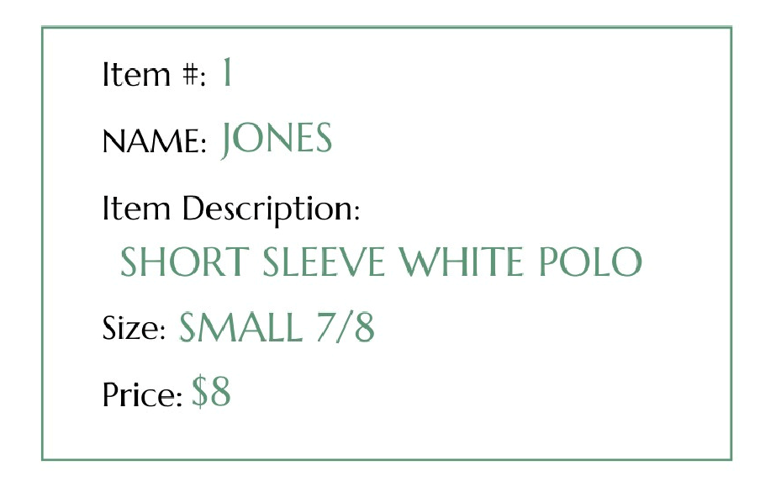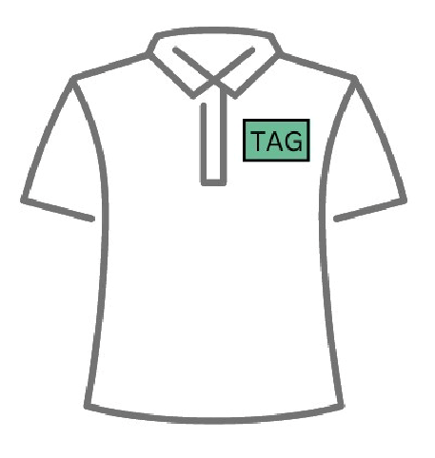
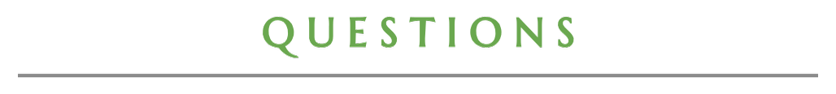
- Any brand that is not Dennis or Lands’ End
- Spirit Shirts
- Socks
- Non-Classroom approved Crusader Wear (ie:hoodies)
- Activity Shirts or Uniforms for extracurricular activities (band, cheer, scouts, soccer, etc.)
2026
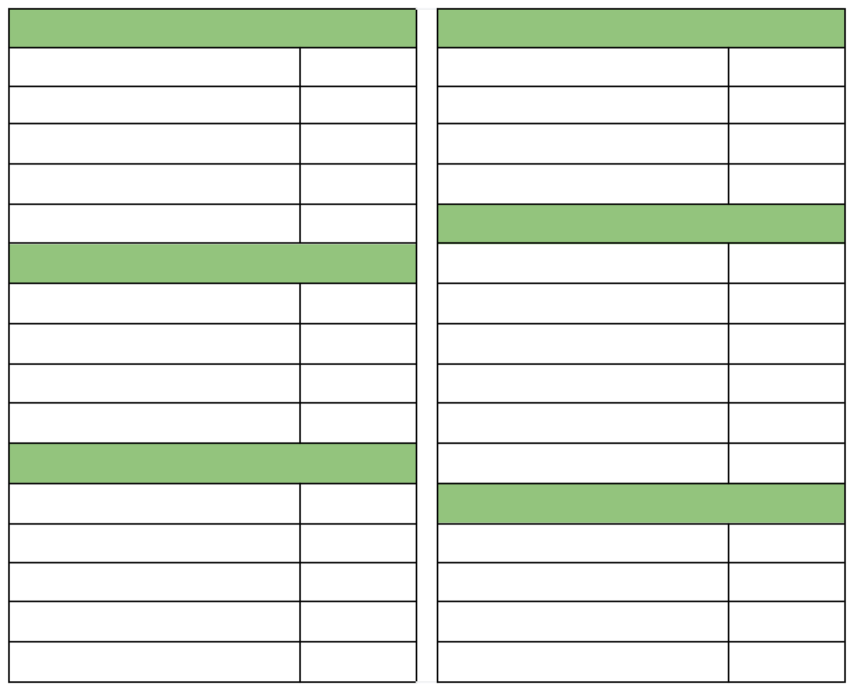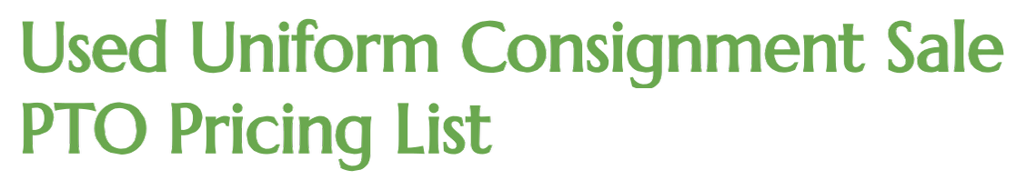
OUTERWEAR
Vest

Pullover Sweater

Cardigan Sweater

Crusader Sweatshirt

Nylon / Fleece Jacket
UNISEX SHIRTS
Short Sleeve Pique Polo

Short Sleeve DryFit Polo

Long Sleeve Pique Polo
Short Sleeve Oxford

Long Sleeve Oxford
PE (Grade 6th-8th Only)
Cotton Shirt

Cotton Shorts

DryFit Shirt

Mesh Shorts
BOYS
Twill Shorts

Tech Shorts

Twill Pants

Tech Pants
GIRLS
Plaid Jumper

Plaid Skort

Plaid Skirt

Khaki / Navy Shorts

Navy / Khaki Pants

Peter Pan Blouse
ACCESSORIES
Belts

Modesty Shorts

Bows / Hair Accessories

Logo Drawstring Backpack
$3
$3
$5
$5
$10
$12
$10
$10
$10
$15
$18
$18
$10
$10
$5
$3
$2
$3
$10
$12
$10
$12
$20
$20
$20
$10
$12
$8
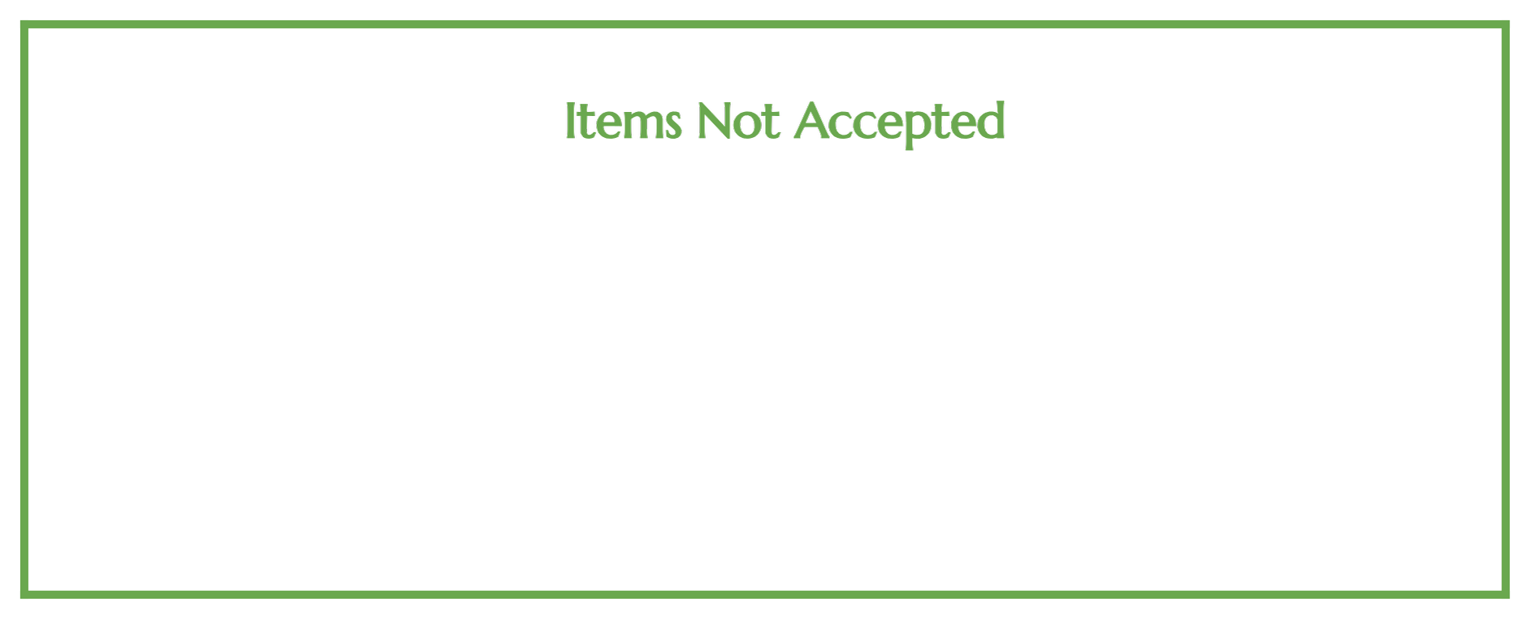
★
★
★
★
★
Any non-Dennis or Lands’ End Uniforms

Spirit Shirts
Socks
Non-Classroom approved Crusader Wear (ie: hoodies)

Activity Shirts or Uniforms for extracurricular activities (band, cheer, scouts,
soccer, etc.)
2026
Family Name:______________________________________________________________________________________
(Make sure your family name is listed on all items dropped off for the sale)
Contact Name:____________________________________________________________________________________
Oldest Child Name:____________________________________ Homeroom Teacher:_________________________
Email:__________________________________________ Phone Number:____________________________________
Mailing Address for Payment:_______________________________________________________________________
__________________________________________________________________________________________________
 I would like my unsold items KEPT for the next sale
I would like my unsold items RETURNED
I would like to DONATE unsold items to St. John’s PTO
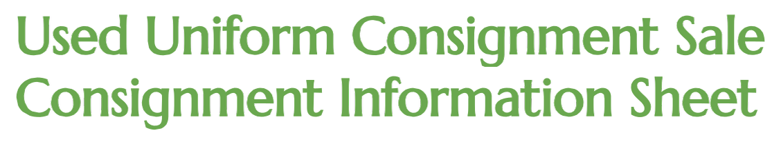

We understand that some families may not want to stay and check in their items. If you would like to drop off, please ensure that you hand your items to a volunteer at check in with all appropriate paperwork. A volunteer will go through the items dropped off and review the inventory sheet. Please initial if you do not wish to check in your items.
___________I would like the used uniform committee to check in my items and accept any changes or discrepancies found during the check in process.

For Committee Use Only
Number of items present at check in:

(Please note any discrepancies from the inventory sheet)
Number of items sold:
Total Sales:

Payment to be mailed (70%):

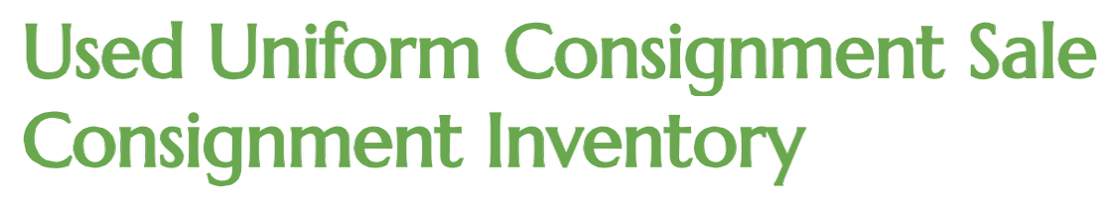Family Name:
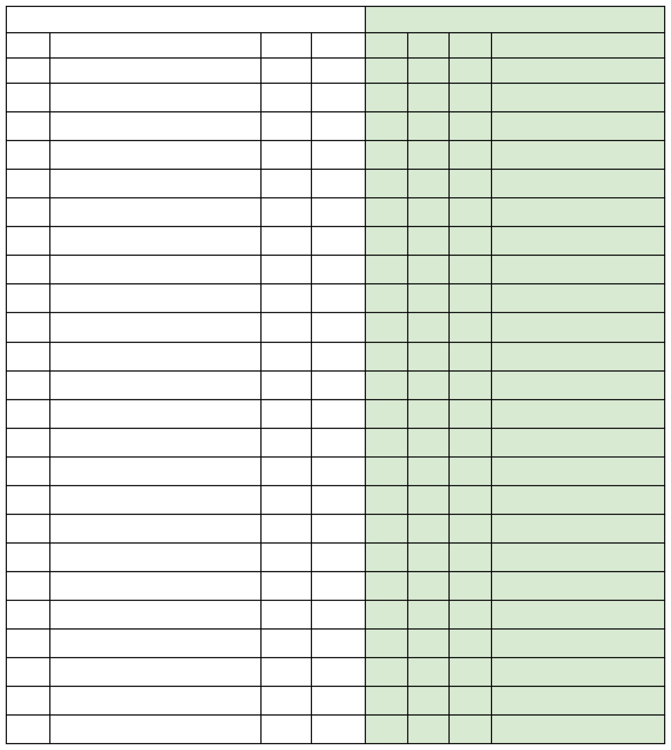
To Be Completed by Consigner
— Completed by Used Uniform Committee —
Item #
Description
Size
Price
Rec’ed
Sold
Return
Comment

Size:
Price:
Item #:
NAME:
Item Description:
Item #:
NAME:
Item Description:
Item #:
NAME:
Item Description:
Item #::
NAME:
Item Description:
Item:
NAME:
Item Description:
Item #:
NAME:
Item Description:
Item #:
NAME:
Item Description:
Item #:
NAME:
Item Description:
Size:
Price:
Size:
Price:
Size:
Price:
Size:
Price:
Size:
Price:
Size:
Price:
Size:
Price:

